Détermination du 1 et 2 octobre
Lieu : Kembs - EXPO 2022
Genre | espèce | variété | Ancien Nom
Abortiporus | biennis
Agaricus | arvensis
Agaricus | augustus
Agaricus | bernardii |  | Agaricus maleolens
Agaricus | bitorquis
Agaricus | campestris |  | Agaricus campestris var. squamulosus
Agaricus | campestris
Agaricus | cappellianus |  | Agaricus vaporarius
Agaricus | macrocarpus
Agaricus | sylvaticus |  | Agaricus haemorrhoidarius
Agaricus | sylvaticus
Agaricus | sylvicola
Agaricus | sylvicola |  | Agaricus essettei
Agaricus | xanthodermus
Aleuria | aurantia
Amanita | abietum |  | Amanita panthrerina fo. abietinum
Amanita | battarrae
Amanita | caesarea
Amanita | ceciliae
Amanita | citrina
Amanita | citrina |  | Amanita citrina var. alba
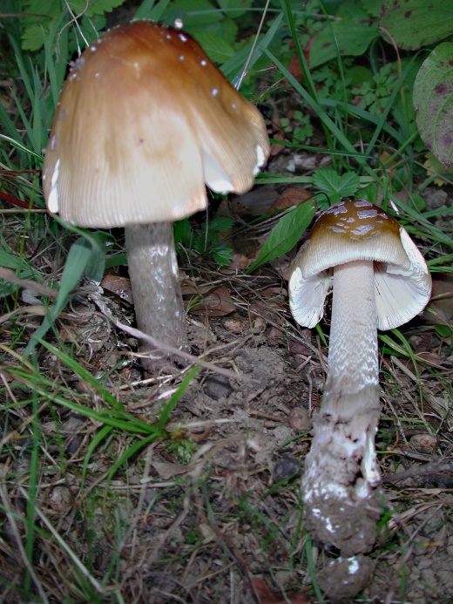  Amanita | crocea
Amanita crocea  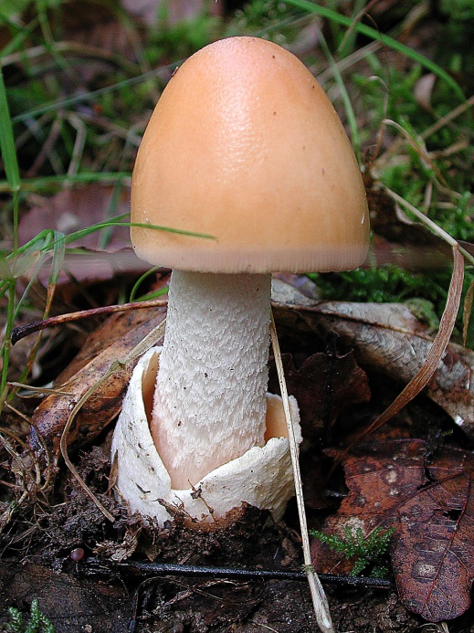  Amanita | excelsa | Amanita ceciliae
Amanita | franchetii
Amanita | fuliginea |  | A. brunneofuliginea var. ochraceomaculata
Amanita | fulva
Amanita | malleata
Amanita | muscaria |  | Amanita muscaria fo. flavivolvata
Amanita | olivaceogrisea
Amanita | pantherina
Amanita | phalloides
Amanita | porphyria
Amanita | rubescens
Amanita | strobiliformis
Amanita | submembranacea
Amanita | vaginata |  | Amanita vaginata var. plumbea
Amanita | virosa
Amaraudon | viridis
Ampulloclitocybe | clavipes |  | Clitocybe clavipes
Apioperdon | piriforme |  | Lycoperdon piriforme
Armillaria | mellea
Artomyces | pyxidatus |  | Clavicorona pyxidata
Aureoboletus | gentilis
Auricularia | mesenterica
Auriscalpium | vulgare
Bjerkandera | adusta
Boletus | edulis
Boletus | ferrugineus
Boletus | pinophilus
Bulgaria | inquinans
Caloboletus | calopus |  | Boletus campestris
Calocera | viscosa
Cantharellus | amethysteus
Cantharellus | cibarius |  | Cantharellus pallens
Cantharellus | cibarius
Cantharellus | ferruginascens
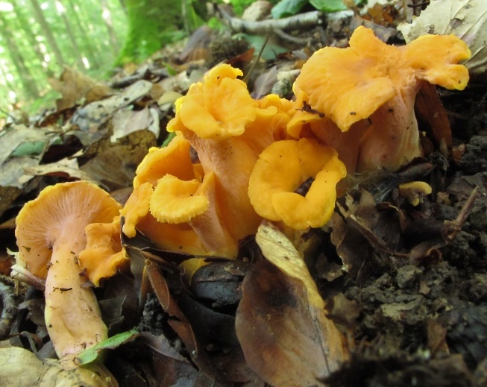  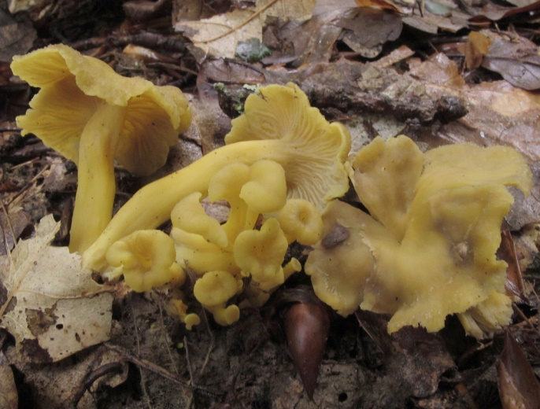  Cantharellus  Craterellus melanoxeros  Cantharellus melanoxeros  Cerioporus leptocephalus Polyporus leptocephalus fo. nummularius | ianthinoxanthus | Craterellus ianthinoxanthus
Cerioporus | varius |  | Polyporus varius
Chalciporus | piperatus
Chroogomphus | rutilus
Chrysomphalina | chrysophylla
Clathrus | archeri
Clavariadelphus | pistillaris
Clavariadelphus | truncatus
Clavulina | coralloides |  | Clavaria cristata
Clavulinopsis | fusiformis |  | Clavaria fusiformis
Clitocybe | catinus
Clitocybe | costata
Clitocybe | dealbata
Clitocybe | nebularis
Clitocybe | odora
Clitocybe | phaeophtalma
Clitocybe | phyllophila
Clitocybe | phyllophila |  | Clitocybe cerussata
Clitocybe | rivulosa
Clitocybe | umbilicata
Clitocybula | lacerata
Clitopaxillus | alexandri |  | Clitocybe alexandri
Clitopilus | geminus |  | Rhodocybe gemina
Clitopilus | prunulus
Collybia | cookei |  | Microcollybia cookei
Gymnopus | erythropus |  | Collybia erythropus
Conocybe | tenera
Coprinopsis | atramentaria |  | Coprinus atramentarius
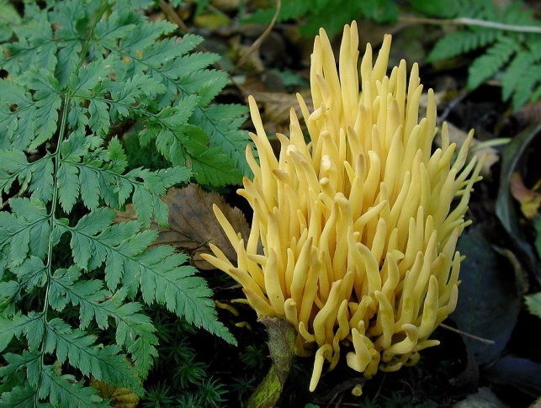  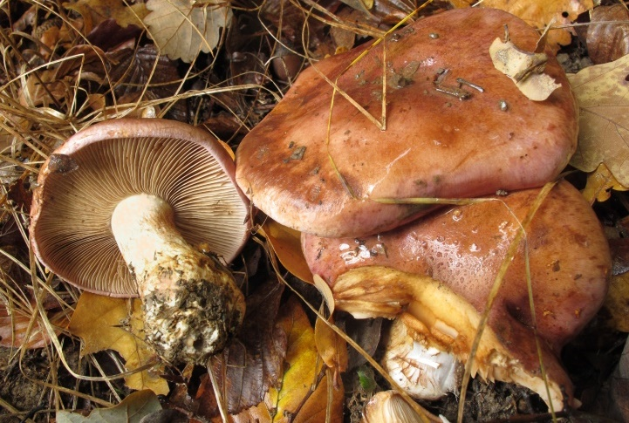  Coprinus  Cortinarius balteatocumatilis  Cortinarius alboviolaceus  Cortinarius anomalus  Cortinarius anomalus Cortinarius azureus  Cortinarius arcuatorum  Cortinarius argutus Cortinarius fraudulosus  Cortinarius armeniacus  Cortinarius atrovirens  Cortinarius balteatocumatilis | comatus | Clavulinopsis fusiformis
Cortinarius | barbarorum
Cortinarius | bivelus
Cortinarius | brunneus
Cortinarius | caerulescens
Cortinarius | caesiolatens
Cortinarius | calochrous
Cortinarius | camphoratus
Cortinarius | caperatus |  | Rozites caperatus
Cortinarius | cinnamomeus
Cortinarius | claricolor
Cortinarius | cliduchus
Cortinarius | collinitus
Cortinarius | croceus
Cortinarius | delibutus
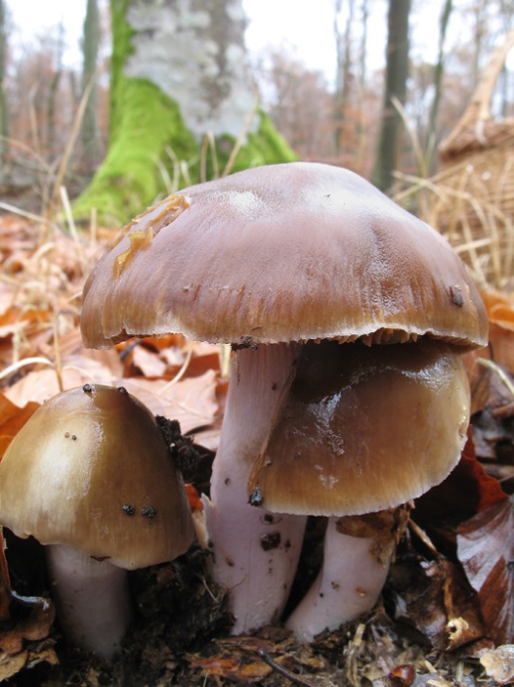  Cortinarius | dibaphus
Cortinarius | dionysae
Cortinarius | elegantior
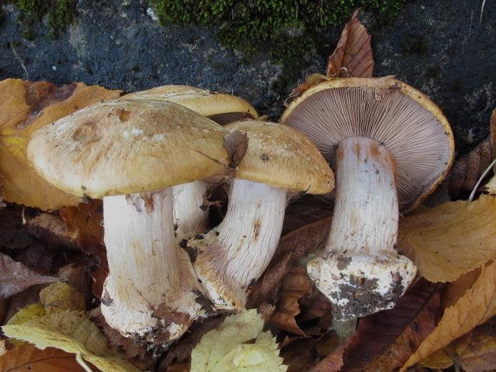  Cortinarius | glaucopus
Cortinarius glaucopus  Cortinarius | glaucopus | Cortinarius mucifluoides | Cortinarius glaucopus fo. acyaneus
Cortinarius | hinnuleovelatus
Cortinarius | hinnuleus
Cortinarius | infractus
Cortinarius | inolens
Cortinarius | jubarinus
Cortinarius | laniger
Cortinarius | largus
Cortinarius | lebretonii
Cortinarius | lividoviolaceus
Cortinarius | malachius
Cortinarius | malicorius
Cortinarius | melanotus
Cortinarius | montanus
Cortinarius | mucifluoides
Cortinarius | multiformium
Cortinarius | odorifer
Cortinarius | olidoamarus
Cortinarius | olidus
Cortinarius | percomis
Cortinarius | praestans
Cortinarius | privignus
Cortinarius | purpurascens |  | Cortinarius subpurpurascens
Cortinarius | purpureus |  | Cortinarius phoeniceus
Cortinarius | renidens
Cortinarius | riederi
Cortinarius | rufoolivaceus
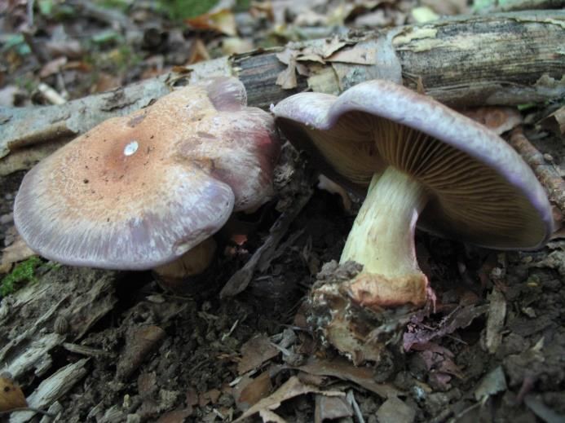  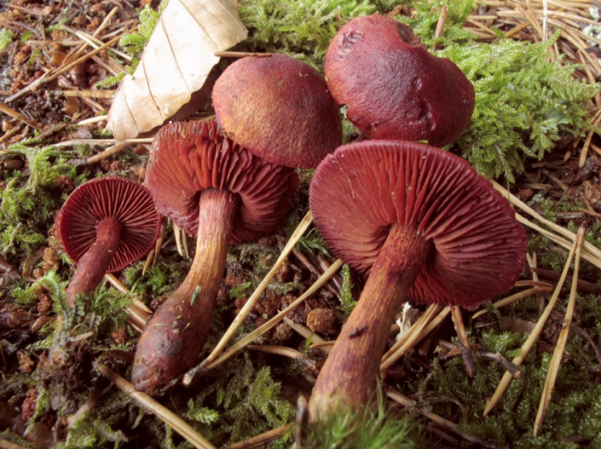  Cortinarius rufoolivaceus  Cortinarius | safranopes | Cortinarius sanguineus
Cortinarius | salor
Cortinarius | sanguineus
Cortinarius | saporatus |  | Cortinarius subturbonatus
Cortinarius | scaurus
Cortinarius | semisanguineus
Cortinarius | stillatitius
Cortinarius | talus
Cortinarius | tomentosus
Cortinarius | torvus
Cortinarius | traganus
Cortinarius | trivialis
Cortinarius | umidicola
Cortinarius | variicolor
Cortinarius | varius
Cortinarius | venetus
Cortinarius | vibratilis
Cortinarius | vulpinus
Cortinarius | xanthocephalus
Craterellus | cornucopioides
Craterellus | lutescens |  | Cantharellus lutescens
Craterellus | tubaeformis |  | Cantharellus tubaeformis
Crepidotus | applanatus
Crepidotus | cesatii
Crepidotus | crocophyllus
Cyanoboletus | pulverulentus |  | Xerocomus pulverulentus
Cyclocybe | aegerita
Cystoderma | amianthinum
Cystoderma | amianthinum |  | Cystoderma amianthinum fo. rugosoreticulatum
Cystoderma | carcharias
Daedaleopsis | confragosa |  | Daedalea confragosa
Daedaleopsis | tricolor
Desarmillaria | tabescens
Echinoderma | asperum
Entocybe | nitida |  | Entoloma nitidum
Entoloma | Chalybeum
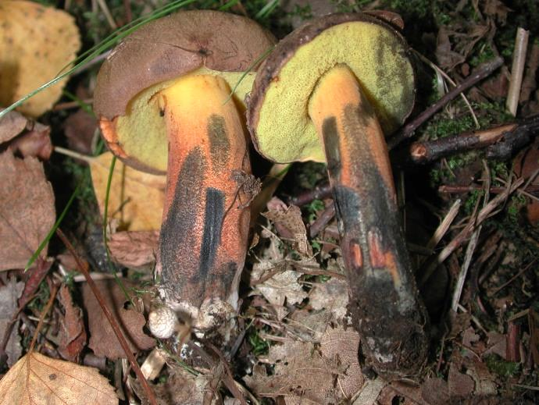  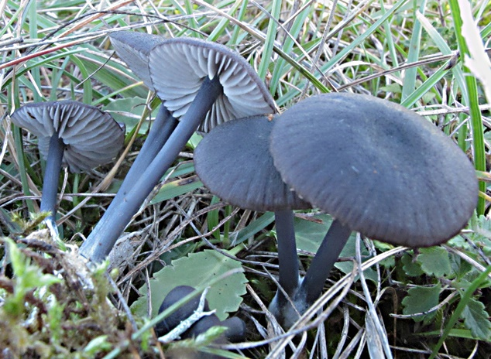  Entoloma chalybaeum  Entoloma | inusitatum | Cyanoboletus pulverulentus
Entoloma | lividoalbum
Entoloma | myrmecophilum
Entoloma | rhodopolium |  | Entoloma nidorosum
Entoloma | rhodopolium
Entoloma | sinuatum |  | Entoloma lividum
Favolaschia | calocera
Fistulina | hepatica
Fomes | fomentarius
Fomitopsis | betulina |  | Piptoporus betulinus
Fomitopsis | pinicola
Ganoderma | applanatum
Ganoderma | carnosum
Ganoderma | lucidum
Gomphidius | glutinosus
Gomphidius | roseus
Gymnopilus | decipiens
Gymnopilus | penetrans
Gymnopilus | junionus |  | Gymnopilus spectabilis
Gymnopus | dryophilus |  | Collybia dryophila
Gymnopus | erythropus |  | Collybia erythropus
Gymnopus | fusipes |  | Collybia fusipes
Hapalopilus | rutilans
Hebeloma | crustuliniforme
Hebeloma | fusisporum
Hebeloma | hetieri
Hebeloma | laterinum |  | Hebeloma edurum
Hebeloma | leucosarx
Hebeloma | leucosarx |  | Hebeloma velutipes
Hebeloma | mesophaeum
Hebeloma | radicosum
Hebeloma | sacchariolens
Hebeloma | sinapizans
Hebeloma | theobrominum
Helvella | crispa
Helvella | elastica
Helvella | macropus
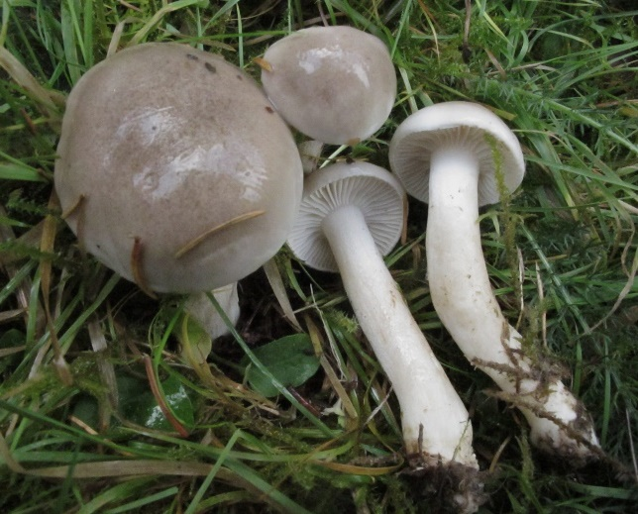  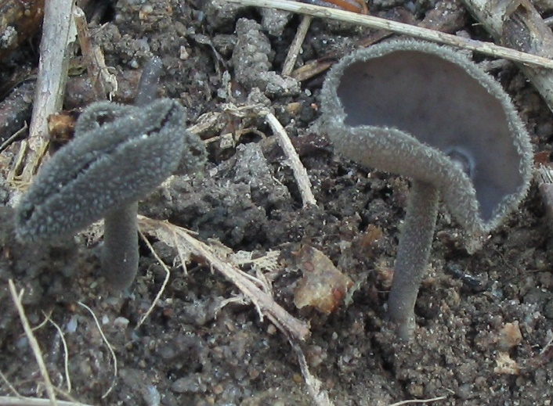  Helvella macropus  Hemileccinum | depilatum | Hygrophorus agathosmus | Xerocomus depilatus
Hericium | erinaceus
Hohenbuehelia | auriscalpium
Hohenbuehelia | petaloides |  | Hohenbuehelia geogenia
Hydnellum | concrescens
Hydnum | repandum
Hydnum | rufescens
Hydnum | umbilicatum
Hygrocybe | acutoconica
Hygrocybe | chlorophana
Hygrocybe | chlorophana |  | Hygrocybe chlorophana var. aurantiaca
Hygrocybe | conica
Hygrocybe | conica |  | Hygrophorus tristis
Hygrocybe | persistens |  | Hygrophorus persistens
Hygrocybe | spadicea
Hygrophoropsis | aurantiaca
Hygrophoropsis | fuscosquamula
Hygrophorus | agathosmus
Hygrophorus | chrysodon |  | Geronema chrysophyllum
Hygrophorus | cossus
Hygrophorus | eburneus
Hygrophorus | erubescens
Hygrophorus | lindtneri
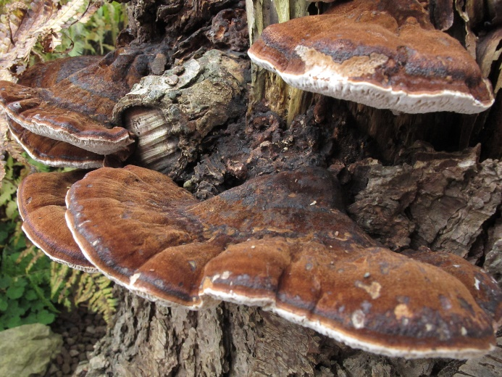  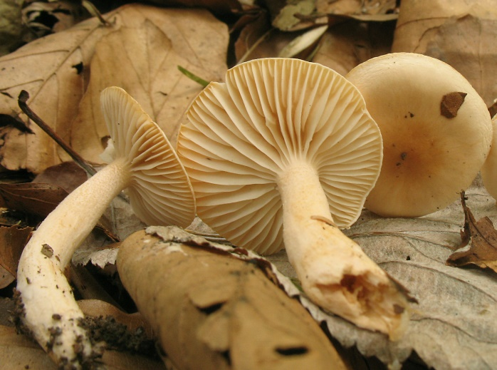  Hygrophorus lindtneri  Hygrophorus | nemoreus | Ischnoderma benzoinum
Hygrophorus | olivaceoalbus
Hygrophorus | pudorinus
Hymenopellis | radicata |  | Xerula radicata fo. marginata
Hymenopellis | radicata
Hypholoma | fasciculare
Hypholoma | lateritium
Hypomyces | lateritius
Imlaria | badia |  | Xerocomus badius
Infundibulicybe | gibba
Inocutis | rheades |  | Inonotus rheades
Inocybe | asterospora
Inocybe | corydalina
Inocybe | eutheles
Inocybe | geophylla
Inocybe | incarnata
Inocybe | tenebrosa
Inosperma | adaequatum |  | Inocybe jurana
Inosperma | bongardii |  | Inocybe bongardii
Inosperma | cervicolor |  | Inocybe cervicolor
Ischnoderma | benzoinum
Kuehneromyces | mutabilis
Laccaria | amethystina
Laccaria | laccata |  | Laccaria affinis
Laccaria | pumila
Lacrymaria | lacrymabunda
Lactarius | acerrimus
Lactarius | albocarneus |  | Lactarius glutinopallens
Lactarius | aurantiacus |  | Lactarius mitissimus
Lactarius | azonites |  | Lactarius fuliginosus
Lactarius | blennius |  | Lactarius blennius var. viridis
Lactarius | blennius
Lactarius | camphoratus
Lactarius | chrysorrheus
Lactarius | circellatus
Lactarius | controversus
Lactarius | decipiens
Lactarius | deliciosus
Lactarius | deliciosus |  | Lactarius deliciosus fo. rubescens
Lactarius | deterrimus
Lactarius | evosmus
Lactarius | fluens
Lactarius | fulvissimus |  | Lactarius britannicus
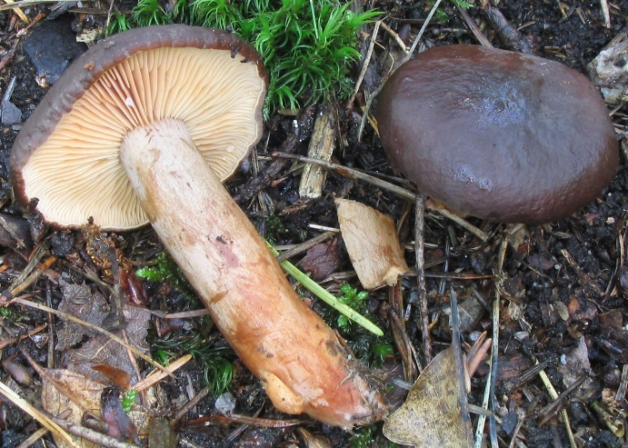  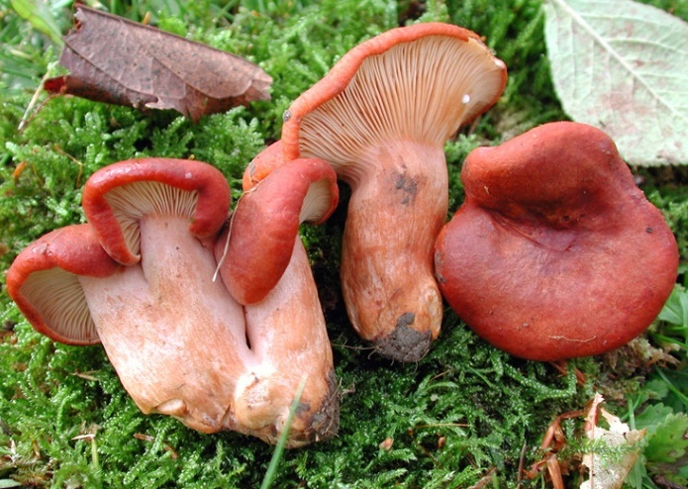  Lactarius fulvissimus  Lactarius | fulvissimus | Lactarius subumbonatus | Lactarius britannicus var.pseudofulvissimus
Lactarius | glyciosmus
Lactarius | hepaticus
Lactarius | lacunarum
Lactarius | necator
Lactarius | pallidus
Lactarius | picinus
Lactarius | pterosporus
Lactarius | pubescens
Lactarius | pyrogalus
Lactarius | quieticolor
Lactarius | quietus
Lactarius | rufus
Lactarius | salmonicolor
Lactarius | scrobiculatus
Lactarius | subdulcis
Lactarius | subumbonatus
Lactarius | tabidus
Lactarius | torminosus
Lactarius | trivialis
Lactarius | uvidus
Lactarius | zonarius
Lactarius | zonarius |  | Lactarius zonarius var. scrobipes
Lactifluus | vellereus
Laetiporus | sulphureus
Leccinellum | crocipodium
Leccinellum | pseudoscabrum |  | leccinum carpini
Leccinum | aurantiacum |  | Leccinum quercinum
Leccinum | chioneum
Leccinum | melaneum
Leccinum | molle
Leccinum | olivaceosum
Leccinum | scabrum
Leccinum | variicolor |  | Cortinarius variecolor
Lentinellus | castoreus
Lentinellus | cochleatus
Lentinellus | inolens
Lentinellus | micheneri |  | Lentinellus micheneri fo. queletii
Lentinellus | ursinus
Lentinus | substricticus |  | Polyporus ciliatus
Lentinus | tigrinus
Lenzites | betulinus
Leotia | lubrica
Lepiota | clypeolaria
Lepiota | cristata
Lepiota | echinella |  | Lepiota setulosa
Lepiota | felina
Lepiota | ignivolvata
Lepiota | lilacea
Lepiota | magnispora |  | Lepiota ventriosospora
Lepiota | ochraceosulfurescens
Lepiota | subincarnata
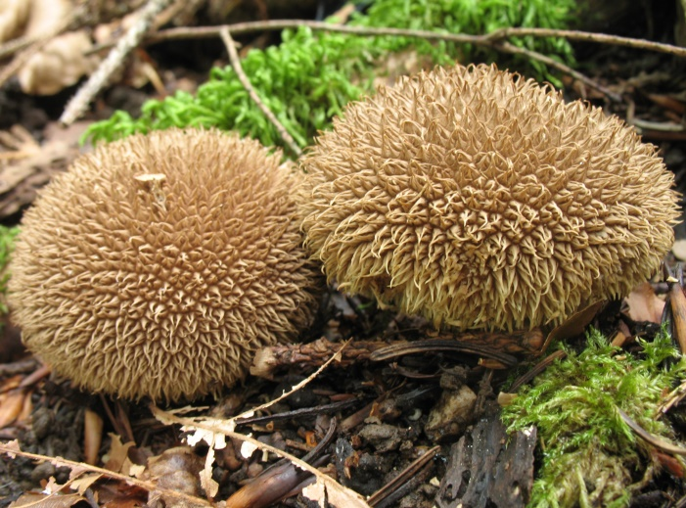  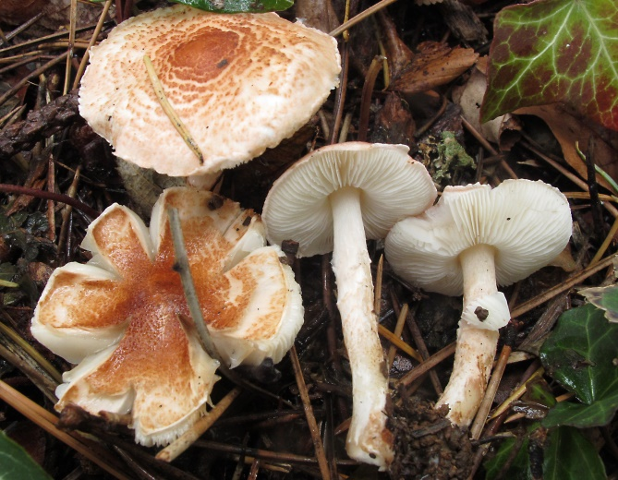  Lepiota subincarnata  Lepista | nuda | Lycoperdon echinatum
Leratiomyces | squamosus |  | Psilocybe squamosa
Leucoagaricus | leucothites
Leucoagaricus | macrorhizus |  | Lepiota macrorhiza
Leucocortinarius | bulbiger
Leucocybe | candicans
Leucocybe | connata |  | Lyophyllum connatum
Lycoperdon | echinatum
Lycoperdon | excipuliforme |  | Calvatia excipuliformis
Lycoperdon | molle
Lycoperdon | nigrescens |  | Lycoperdon foetidum
Lycoperdon | perlatum
Lycoperdon | pratense |  | Vascellum pratense
Lyophyllum | decastes
Lyophyllum | decastes |  | Lyophyllum fumosum
Lyophyllum | paelochroum
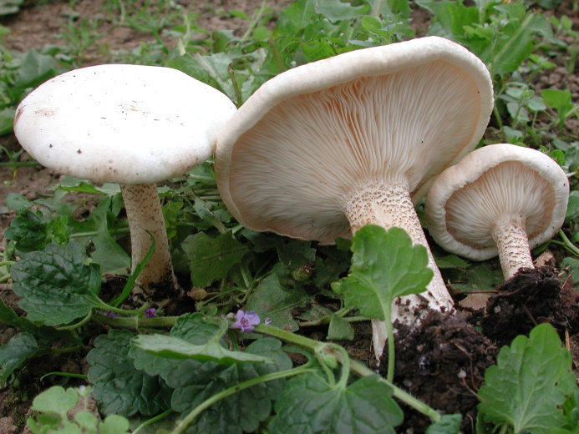  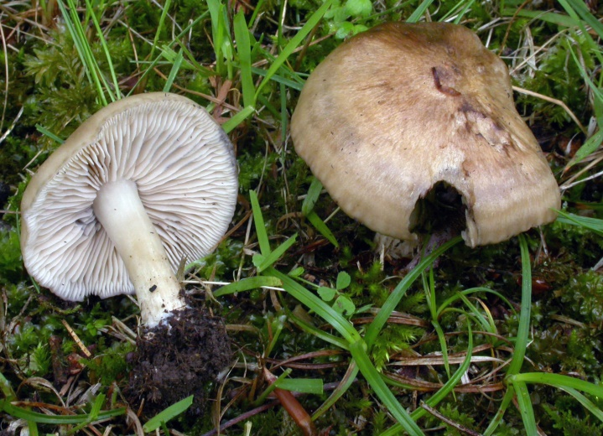  Lyophyllum paelochroum  Macrolepiota | fuliginosa | Melanoleuca verrucipes
Macrolepiota | mastoidea |  | Macrolepiota gracilenta
Macrolepiota | mastoidea
Macrolepiota | procera
Marasmiellus | confluens |  | Collybia confluens
Marasmiellus | peronatus |  | Collybia peronata
Marasmiellus | ramealis
Marasmius | oreades
Marasmius | wynneae
Megacollybia | platyphylla
Melanoleuca | grammopodia
Melanoleuca | polioleuca
Melanoleuca | verrucipes
Meripilus | giganteus
Mucidula | mucida |  | Oudemansiella mucida
Mutinus | caninus
Mycena | aurantiomarginata
Mycena | crocata
Mycena | epipterygia
Mycena | galericulata
Mycena | inclinata
Mycena | metata
Mycena | olivaceomarginata
Mycena | pelianthina
Mycena | pura
Mycena | pura |  | Mycena pura fo. alba
Mycena | renati
Mycena | rosea
Mycena | vitilis
Mycetinis | alliaceus |  | Marasmius alliaceus
Mycetinis | scorodonius
Neoboletus | erythropus
Neoboletus | luridiformis |  | Boletus erythropus var. discolor
Nothopanus | candidissimus
Otidea | alutacea
Otidea | mirabilis
Otidea | onotica
Oudemansiella | melanotricha |  | Xerula melanotricha
Panellus | stipticus
Panus | conchatus
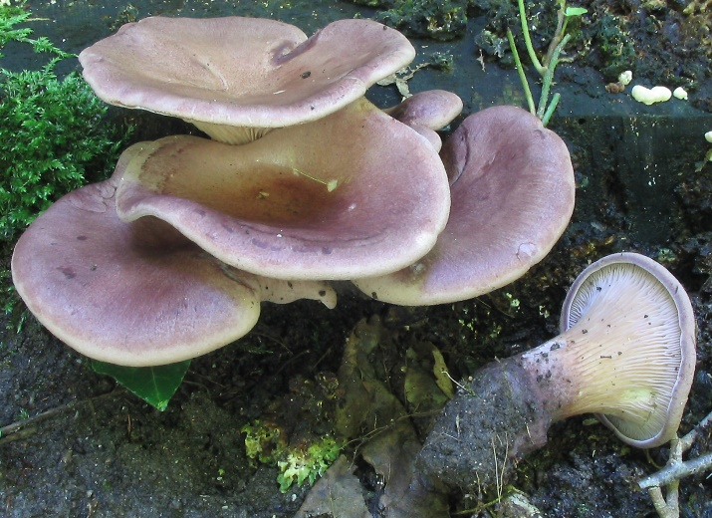  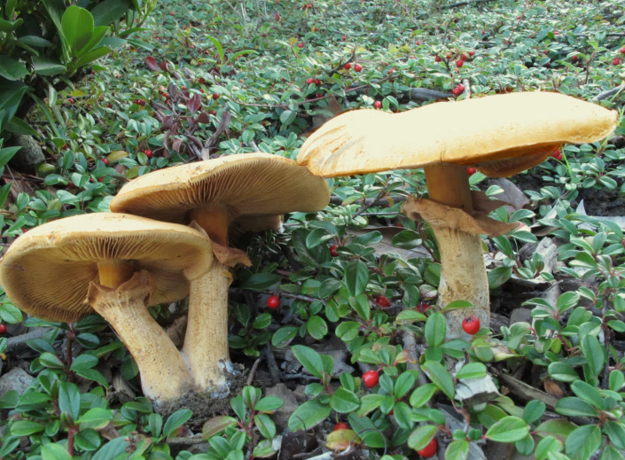  Panus conchatus  Paralepista | flaccida | Phaeolepiota aurea | Clitocybe flaccida
Paxillus | ammoniavirescens
Paxillus | involutus
Peniophora | quercina
Phaeoclavulina | flaccida |  | Clavaria flaccida
Phaeolepiota | aurea
Phaeolus | schweinitzii
Phellodon | niger
Pholiota | adiposa
Pholiota | astragalina
Pholiota | conissans
Pholiota | gummosa
Pholiota | lenta
Pholiota | squarrosa
Pholiota | tuberculosa |  | Pholiota curvipes
Pleurocybella | porrigens |  | Nothopanus porrigens
Pleurotus | ostreatus
Pleurotus | pulmonarius
Pluteus | aurantiorugosus
Pluteus | cervinus
Pluteus | ephebeus
Pluteus | salicinus
Pogonoloma | spinulosum |  | Porpoloma spinuosum
Polyporus | alveolarius |  | Polyporus mori
Polyporus | tuberaster
Porphyrellus | porphyrosporus |  | Boletus porphyrosporus
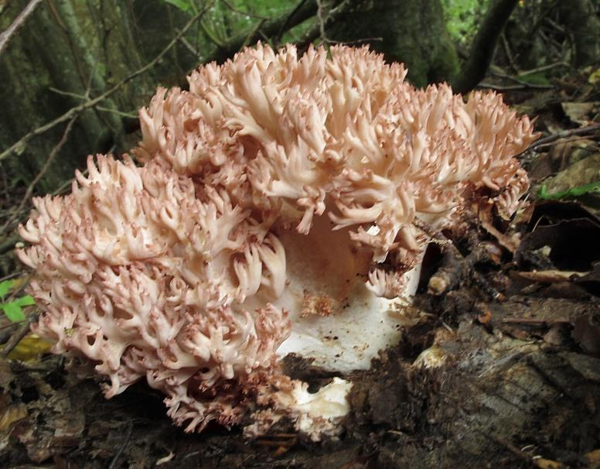  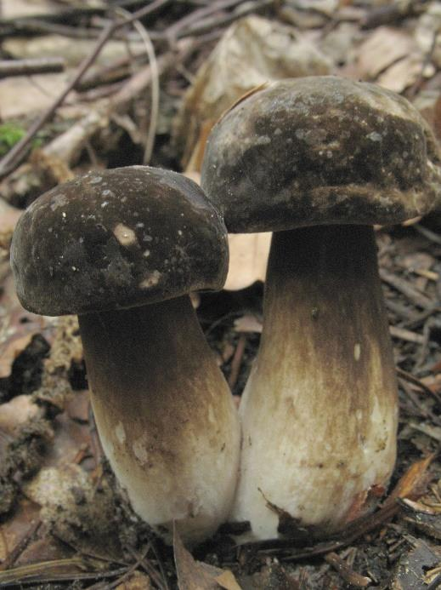  Porphyrellus porphyrosporus  Postia | Ramaria botrytis  ptychogaster |  | Ptychogaster albus
Postia | ptychogaster |  | Tyromyces ptychogaster
Psathyrella | maculata
Psathyrella | multipedata
Psathyrella | piluliformis
Pseudocraterellus | undulatus |  | Cantharellus sinuosus
Pseudohydnum | gelatinosum
Pseudosperma | rimosum |  | Inocybe fastigiata
Psilocybe | coronilla |  | Stropharia coronilla
Pycnoporus | cinnabarinus
Ramaria | aurea |  | Clavaria aurea
Ramaria | botrytis |  | Clavaria botrytis
Ramaria | flava |  | Clavaria flava
Ramaria | formosa |  | Clavaria formosa
Ramaria | myceliosa |  | Clavaria myceliosa
Ramaria | pallida |  | Clavaria pallida
Ramaria | stricta |  | Clavaria stricta
Rheubarbariboletus | armeniacus |  | Xerocomus armeniacus
Rhodocollybia | butyracea |  | Collybia butyracea
Rhodocollybia | butyracea |  | Collybia butyracea var. azema
Rhodocollybia | maculata |  | Collybia maculata
Rhodophana | nitellina |  | Rhodocybe nitellina
Rugosomyces | chrysenteron |  | Lyophyllum chrysenteron
Russula | adusta |  | Russula nigricans
Russula | aeruginea
Russula | albonigra
Russula | alutacea
Russula | amethystina
Russula | amoenolens
Russula | anthracina |  | Russula anthracina var. insipida
Russula | aquosa
Russula | atropurpurea
Russula | atropurpurea | var. depallens
Russula | aurea |  | Russula aurata
Russula | azurea
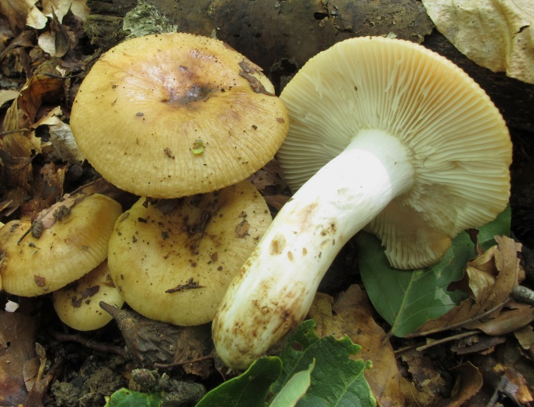  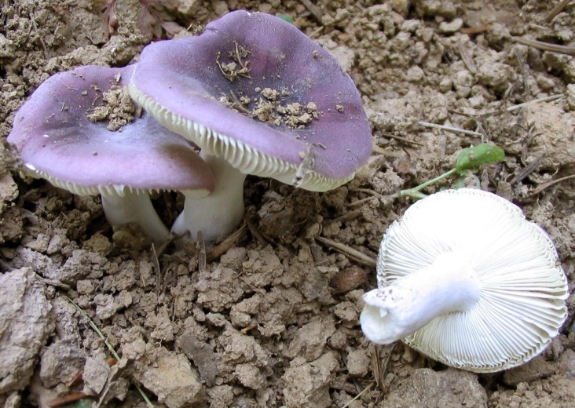  Russula azurea  Russula | badia | Russula farinipes
Russula | betularum
Russula | chloroides
Russula | claroflava
Russula | cremeoavellanea
Russula | cyanoxantha
Russula | cyanoxantha |  | Russula cutefracta
Russula | cyanoxantha |  | Russula cyanoxantha var. peltereaui
Russula | decipiens
Russula | delica |  | Russula delica var. puta
Russula | densifolia
Russula | faginea
Russula | farinipes
Russula | foetens
Russula | fragilis
Russula | grata |  | Russula laurocerasi
Russula | graveolens
Russula | grisea
Russula | heterophylla
Russula | insignis
Russula | integra
Russula | integra |  | Russula integra var. oreas
Russula | integra |  | Russula integra fo. purpurella
Russula | intermedia
Russula | laeta
Russula | langei
Russula | luteotacta
Russula | luteoviridans
Russula | maculata
Russula | medullata
Russula | melliolens
Russula | nobilis |  | Russula fageticola
Russula | ochracea
Russula | ochroleuca
Russula | olivacea
Russula | parazurea
Russula | persicina
Russula | puellaris
Russula | queletii
Russula | risigallina
Russula | romellii
Russula | rosea |  | Russula lepida
Russula | rosea |  | Russula lepida var. lactea
Russula | rosea |  | Russula lepida var. speciosa
Russula | rubroalba
Russula | sanguinaria
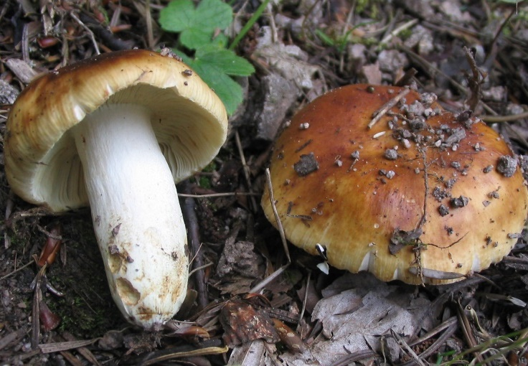  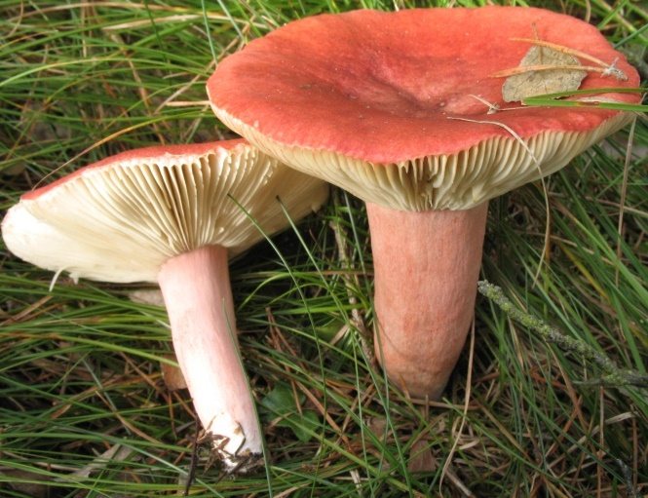  Russula sanguinaria  Russula | sardonia | Russula subfoetens | Russula drimeia
Russula | sericatula
Russula | silvestris
Russula | solaris
Russula | sororia
Russula | subfoetens
Russula | subterfurcata
Russula | turci
Russula | velenovskyi
Russula | vesca
Russula | vesca | fo. avellanea
Russula | vinosobrunnea
Russula | violeipes
Russula | violeipes |  | Russula violeipes fo. citrina
Russula | virescens
Russula | viscida
Sarcodon | imbricatus
Sarcodon | squamosus |  | Hydnum squamosum
Scleroderma | areolatum
Scleroderma | bovista
Scleroderma | citrinum
Laeticutis | cristata |  | Scutiger cristatus
Sparassis | crispa
Sparassis | laminosa
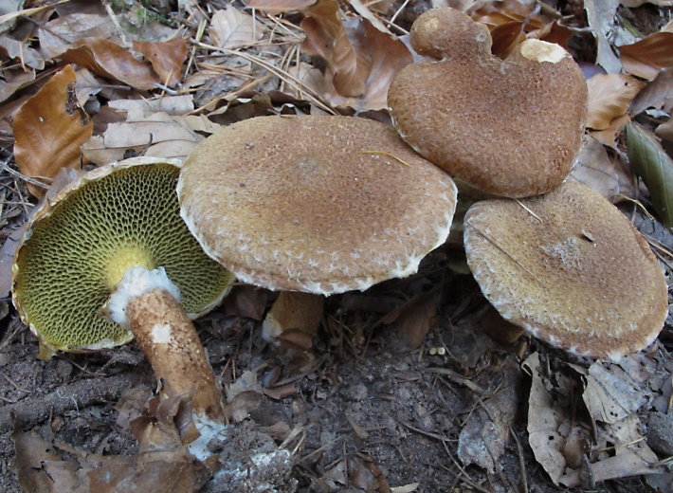  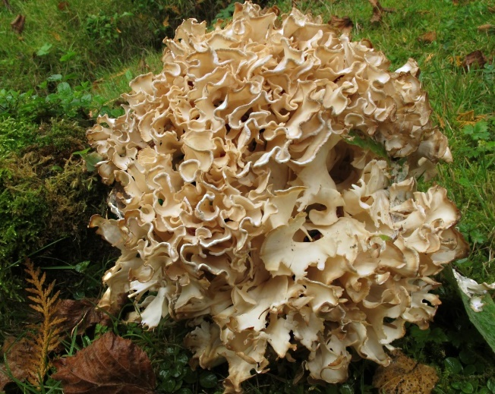  Sparassis laminosa  Strobilomyces | strobilaceus | Suillus cavipes
Stropharia | aeruginosa
Suillelus | luridus |  | Boletus luridus
Suillelus | luridus |  | Boletus luridus var. queletiformis
Suillelus | queletii |  | Boletus queletii
Suillelus | rubrosanguineus
Suillus | bovinus
Suillus | cavipes
Suillus | collinitus
Suillus | grevillei
Suillus | luteus
Suillus | variegatus
Suillus | viscidus
Tapinella | atrotomentosa |  | Paxillus atrotomentosus
Tarzetta | spurcata
Tephrocybe | rancida
Thaxterogaster | collocandoides |  | Cortinarius collocandoides
Trametes | gibbosa
Trametes | versicolor
Tremella | mesenterica
Tremella | steidleri
Tricholoma | acerbum
Tricholoma | album
Tricholoma | atrosquamosum
Tricholoma | bufonium
Tricholoma | columbetta
Tricholoma | luridum
Tricholoma | orirubens
Tricholoma | pardinum
Tricholoma | pseudonictitans
Tricholoma | saponaceum
Tricholoma | saponaceum |  | Tricholoma saponaceus var. ardosiacum
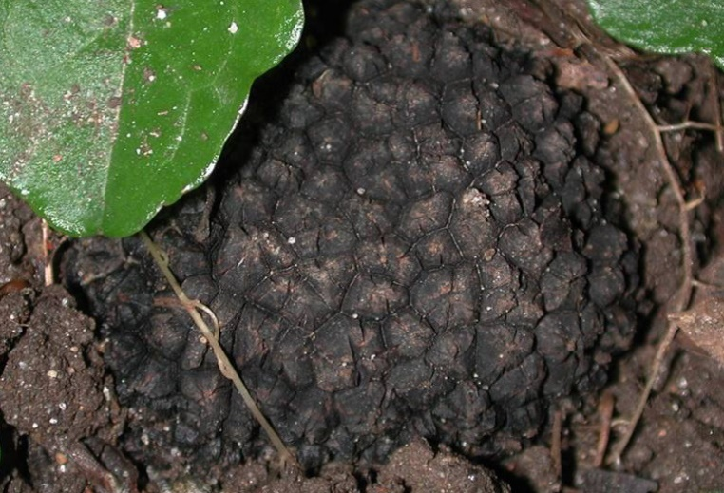  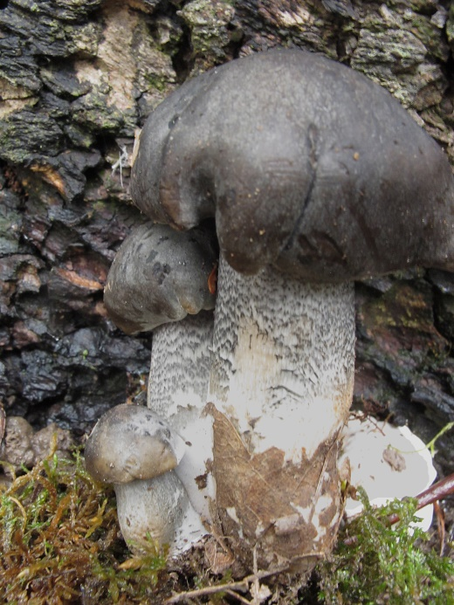  Tricholoma saponaceum  Tricholoma | Tuber uncinatum  scalpturatum
Tricholoma | sejunctum
Tricholoma | sulphureum
Tricholoma | ustale
Tricholoma | ustaloides
Tricholoma | vaccinum
Tricholomopsis | decora
Tricholomopsis | rutilans |  | Tricholoma rutilans
Tuber | excavatum
Tuber | melanosporum
Tuber | rufum
Tuber | uncinatum
Tyromices | lacteus |  | Oligoporus lacteus
Tyromyces | kmetii
Vanderbylia | fraxinea |  | Perenniporia fraxinea
Volvariella | bombycina
Volvopluteus | gloiocephalus |  | Volvariella gloiocephala
Xerocomellus | chrysenteron
Xerocomellus | porosporus |  | Boletus porosporus
Xerocomellus | pruinatus |  | Boletus pruinatus
Xerocomellus | ripariellus
Xerocomus | subtomentosus
Xerula | pudens
Déterminateurs : Daniel Doll – Thomas Isarno - Fabien Sarraillon
Liste élaborée par : Daniel Fischer
Photos : Jean-Luc Muller sauf :
Fabien Sarraillon pour : H. macropus - I. tenebrosa - L. subumbonatus - P. conchatus -R. subfoetens – R. azurea
Jacques Grandhay pour : L. paelochroum

