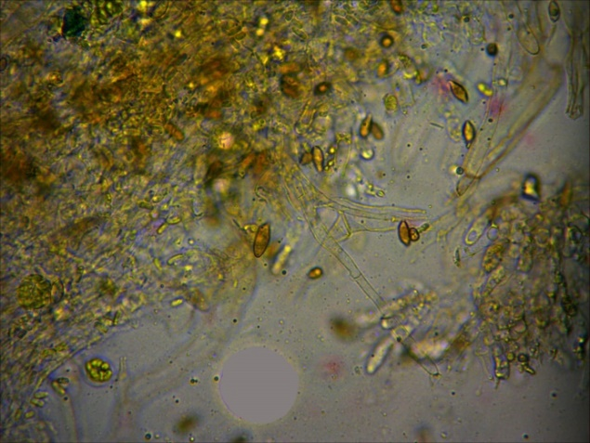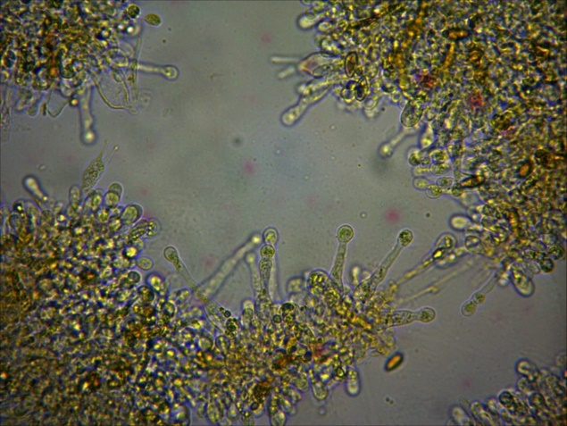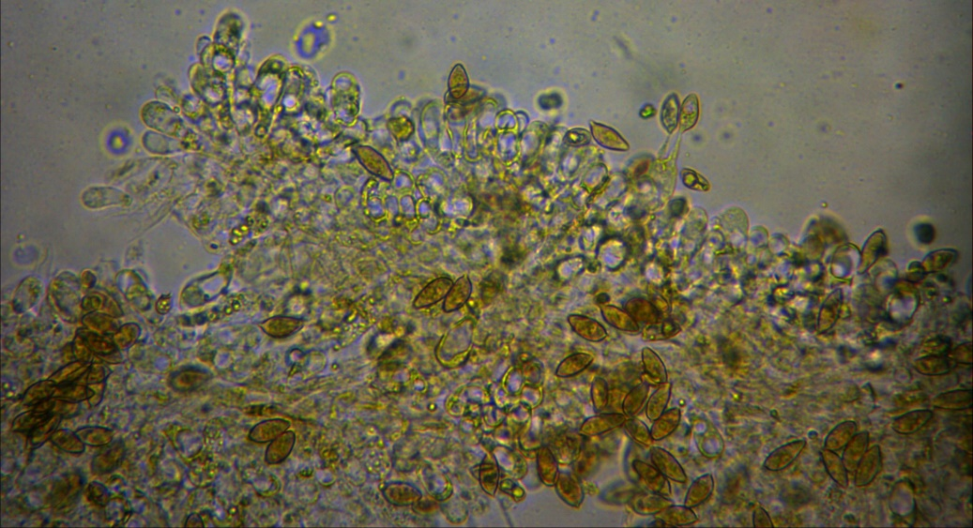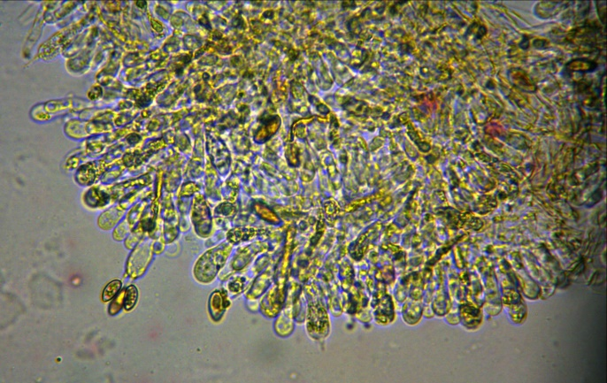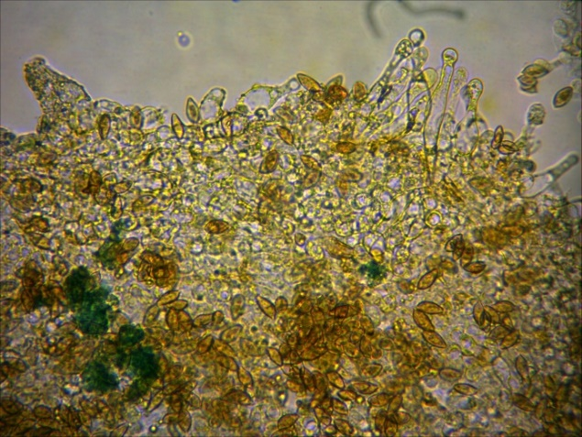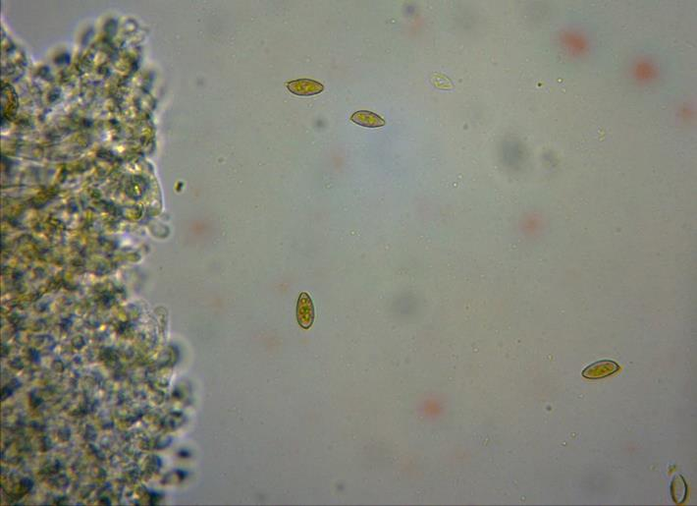

*Galerina jaapii*

p. 14 – Hyphes

p. 13 – Cheilocystides (2)

p. 10 – Basides

p. 12 – Cheilocystides (1)

p. 11 – Basides

p. 9 - Spores 12–15 x 6-7 µm